The instruction about WT901WIFI.

1. Please Install the CH340 drive for the connection with PC by data cable as below:

https://wiki.wit-motion.com/english/doku.php?id=inclinometer

Device driver:[CH340](https://wiki.wit-motion.com/english/lib/exe/fetch.php?media=communication_module:device_driver:ch340%E9%A9%B1%E5%8A%A8.zip)(Please find the drive as the icon)

1.Reading:

The WT901WIFI has two data transmission modes(TCP/UDP) for the work

One is TCP, which send data to the server(cloud),which can be viewed on WeChat public account and client One is UDP, which transfers data to the mobile APP and can view data in the APP. The module factory default is UDP transmission

This data transmission(UDP) mode is suitable for the connection with APP and PC software

2.Connect the WT901WiFi with network.

Please make sure that the devices (PC software / app and WT901WiFi) should under the same network for the connection successfully.

And the concrete operations shown as the pictures as below:

2.1 Change the  PC Distribute Network Software in English Version as the picture: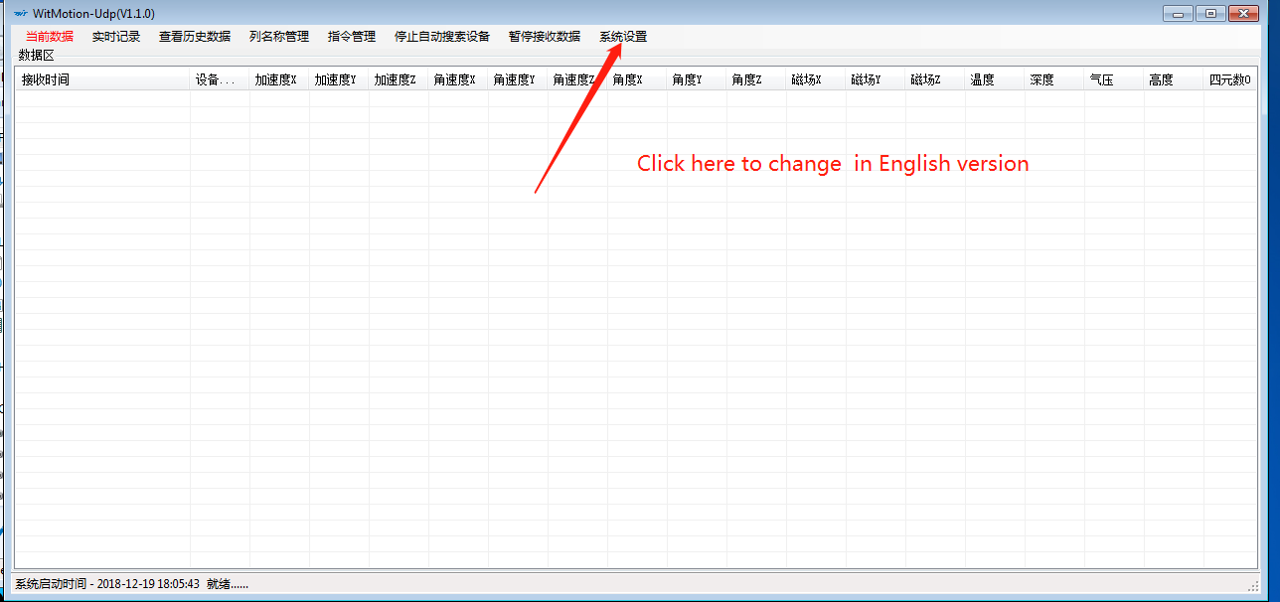

2.2 Distribute the network as  the picture :

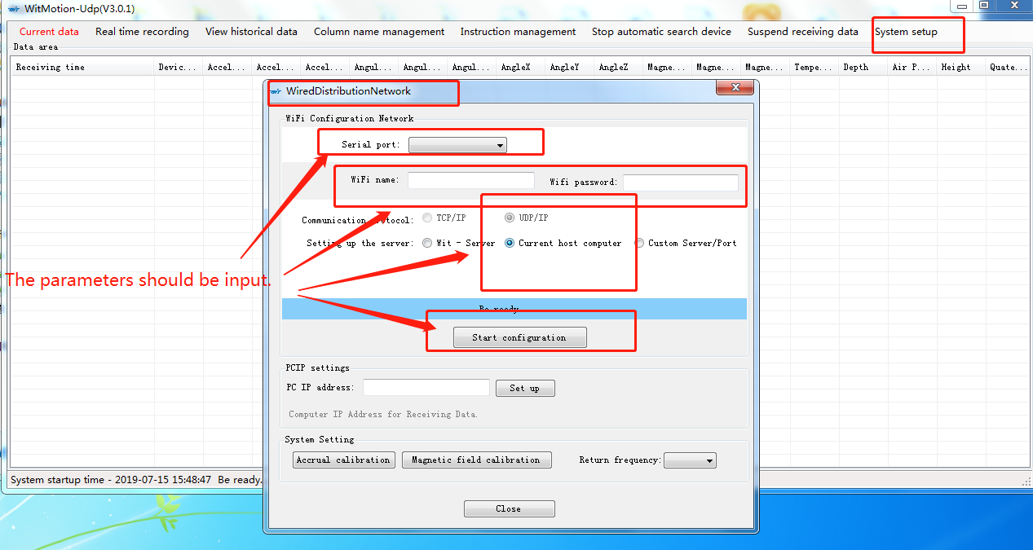

.(The lamp will show in the state of blue all the time if you make it successfully.)

3.Connetion with PC software:

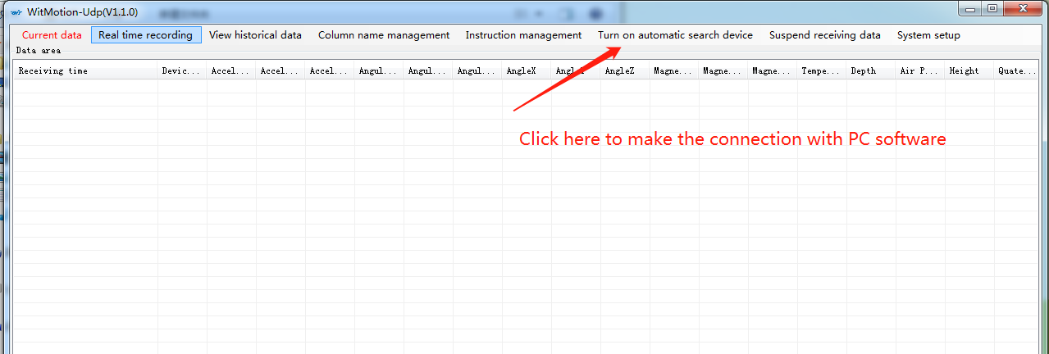

And you will find the data shown on the listing.(It means that you have made the operation successfully.

4.Connection with APP:

Please close the PC software and re-open the switch on WT901WIFI.

Download the app on your phone and open it.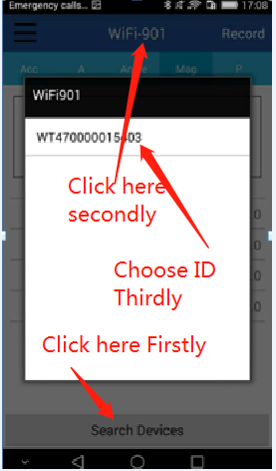

Make the steps as the picture above.

You will view the data shown on app as as below:

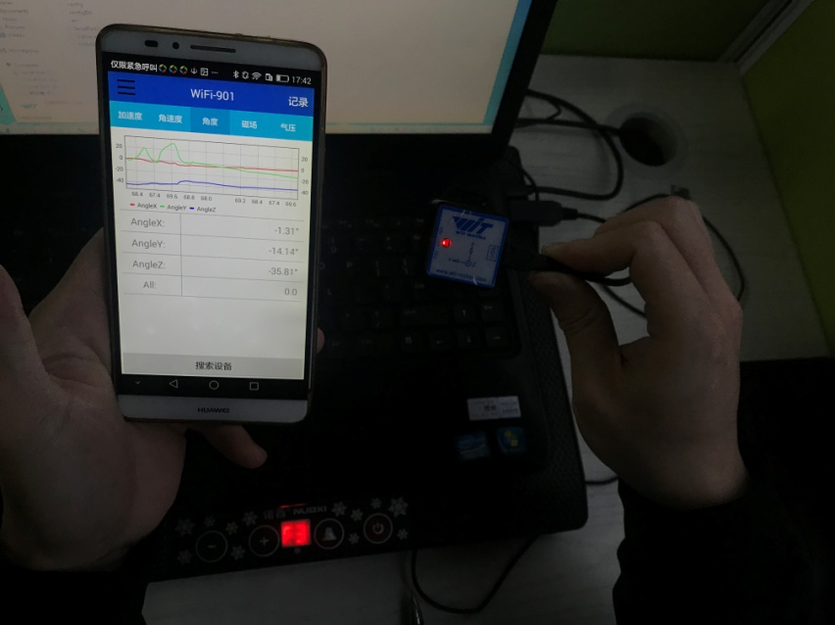

5 About the calibrations

5.1The calibration for acceleration

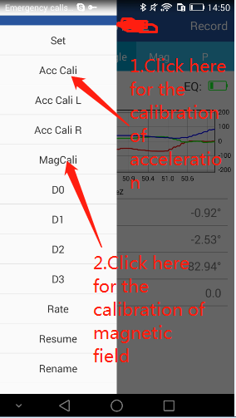

5.1.1Please make sure that the WT901WIFi has been placed at a level position.

5.1. 2.Click the button "Acc Cali"

And you will view the graph lines been stationary.(It means that you have make the calibration about acceleration successfully.

5.1. 3.Click the button "Finished

5.2About the calibration of magnetic field.

5.2.1. What is the idea for the calibration of magnetic field.

Magnetic field calibration is used to remove the magnetic field sensor's zero offset. Usually, the magnetic field sensor will have a large zero error when it is manufactured. If it is not calibrated, it will bring about a large measurement error and affect the accuracy of the Z-axis angle measurement of the heading angle.

5.2.2.The steps as below:

Calibration methods as follow:

1. When calibrating, place the WT901WIFI in a place far away from the disturbing magnetic field (ie, more than 20 CM away from magnets and iron, etc.),

2.Click the button "MagCali"

3. Then slowly rotate the WT901WIFI around the three axis,you can rotate a few more times, and after you draw a more regular ellipse, you can stop the calibration and then Click the button "Finished"

6.You have finished the connection with WT901WIFI and made the calibration for it successfully.